Theory of Lifespan Decline
Jaba Tkemaladze
E-mail: jtkemaladze@longevity.ge
Citation: Tkemaladze, J. (2025). Theory of Lifespan Decline. Longevity Horizon, 1(3). doi : https://doi.org/10.5281/zenodo.17142909

Abstract
The dramatic decline in human lifespan described in the biblical genealogies of Genesis 5 and 11 presents a unique intersection of theological narrative and biological inquiry. This paper proposes a multidisciplinary theory to explain this phenomenon, integrating textual analysis with principles from biogerontology and population genetics. We argue that the Genesis Flood narrative represents a catastrophic event that triggered a fundamental shift in human life-history strategy. Statistical analysis of the biblical data reveals a synchronized decline in total lifespan, age at sexual maturity, and reproductive window—a triad consistent with an adaptive transition from a slow to a fast life-history strategy in response to postdiluvian environmental harshness and a genetic bottleneck. This model explains the decline as a trade-off favoring rapid reproduction over somatic maintenance. The case of Job’s divinely granted 140 years is analyzed not as a reversion to antediluvian norms, but as a supernatural blessing within the new biological paradigm, affirming divine sovereignty over natural law. The study concludes that the biblical account, while theological in purpose, exhibits an internal consistency with modern biological principles, offering a coherent framework for understanding this ancient mystery.

Keywords: Lifespan Decline, Biogerontology, Life-History Theory, Genetic Bottleneck, Postdiluvian Adaptation, Biblical Longevity, Somatic Maintenance, Reproductive Trade-Off, Divine Action.

Introduction: Problem Statement and Research Relevance
The Book of Genesis presents a profound and persistent enigma that has captivated theologians, historians, and scientists for centuries: the extraordinary lifespan of the antediluvian patriarchs, followed by a rapid and systematic decline in human longevity following the Genesis Flood narrative. This phenomenon, documented in the genealogical records of Genesis 5 and 11, describes life spans approaching a millennium, which precipitously drop to ages more familiar to modern humans within a few generations. A further unique case is presented in the Book of Job, where the eponymous protagonist is granted an additional 140 years of life after his trials (Job 42:16), a singular event of divinely orchestrated lifespan extension in the postdiluvian era.

The object of this research is this tripartite biblical phenomenon: 1) the exceptional longevity of the antediluvian figures from Adam to Noah, 2) the dynamic reduction in life expectancy observed in their postdiluvian descendants from Shem to Abraham, and 3) the specific supernatural intervention in the lifespan of Job. Traditional exegetical approaches have often treated these accounts as purely theological or symbolic narratives. However, a purely theological interpretation, while rich in meaning, leaves fundamental questions about the proposed mechanisms of such longevity and its decline unanswered. Conversely, a solely naturalistic approach risks dismissing the narrative integrity and cultural-linguistic context of the texts.

The relevance and urgency of this study, therefore, lie in the necessity of a robust interdisciplinary approach. This research bridges the gap between theological inquiry and empirical science by integrating biblical exegesis with insights from modern gerontology, genetics, climatology, and demography (Fontana, Partridge, & Longo, 2010; López-Otín, Blasco, Partridge, Serrano, & Kroemer, 2013). The rapid advancement of biogerontology, particularly in understanding the genetic and environmental determinants of aging, provides a novel framework for re-examining these ancient texts. For instance, research into the genetics of longevity, epigenetic clocks, and the impact of environmental stressors on lifespan offers potential models for conceptualizing a drastic shift in human biological parameters (Field, Rajewski, & Marcotte, 2020; Sen et al., 2016). This study posits that the biblical chronology, when analyzed as a dataset reflecting a deep cultural memory of a primordial shift, can be critically examined against contemporary scientific models of aging and population dynamics.

The primary aim of this article is to systematically categorize, synthesize, and critically evaluate the leading hypotheses that attempt to explain these biblical longevity phenomena. A special emphasis will be placed on testing established biogerontological principles against the chronological data provided in the scriptures. This involves investigating whether correlations observed in modern biology—such as the relationship between the onset of sexual maturity, reproductive span, and total lifespan—are reflected in the biblical genealogical patterns (Ricklefs, 2010; Tacutu et al., 2018). The goal is not to "prove" the biblical account scientifically but to explore whether these ancient records can be contextualized within a scientific dialogue about the plasticity and determinants of the human lifespan.

To achieve this aim, a multi-faceted methodology will be employed:
- Comparative Textual Analysis: A close exegetical reading of the source texts (Genesis 5, 11, and Job 42:16) in their original linguistic and historical context to establish an accurate foundational dataset of the reported ages and life events.
- Historical-Critical Method: Contextualizing these texts within the broader literary traditions of the Ancient Near East (e.g., Sumerian King Lists) to distinguish potential symbolic numerological patterns from unique claims.
- Statistical Analysis: Quantitative evaluation of the biblical genealogical data to map the precise trajectory of lifespan decline and calculate related metrics, such as the age at the birth of the firstborn and the estimated length of the reproductive window across generations.
- Scientific Reconstruction: Building interdisciplinary models based on current scientific literature to propose plausible natural mechanisms that could theoretically underpin such a dramatic shift in human longevity, consistent with the biblical timeline of a catastrophic global event.

This study contends that a dialogue between theology and science on this issue is not only possible but necessary for a holistic understanding. By engaging with the text seriously as both scripture and a subject for scientific inquiry, this research seeks to contribute to a richer, more nuanced conversation about one of the Bible's most intriguing accounts.

The Antediluvian World: Analysis of Biblical and Extra-Biblical Evidence for Longevity
The Genesis narrative presents a foundational account of human origins, with its fifth chapter providing a precise genealogical record from Adam to Noah, characterized by lifespans vastly exceeding modern human limits. This chapter conducts a critical analysis of this biblical data, explores parallel traditions from the ancient Near East, and examines the theological significance attributed to this exceptional longevity within the scriptural framework.

Biblical Data: Statistical Analysis of the Patriarchs in Genesis 5
The genealogical list in Genesis 5 is structured formulaically, recording each patriarch’s age at the birth of his firstborn son, the remaining years of his life, and his total lifespan. A statistical analysis of this data reveals profound patterns. The ten patriarchs from Adam to Noah exhibit a mean average lifespan of 857.8 years, with a median of 907.5 years (Hendel, 2012). The range is significant, from Noah’s 950 years to Enoch’s unique 365 years, after which "he was not, for God took him" (Gen. 5:24). Notably, the age at which each patriarch fathers the next key figure in the lineage shows less variation, with an average of 115.6 years. Methuselah holds the record for the longest lifespan at 969 years.

Beyond simple averages, the data suggests a subtle, non-linear decline in longevity even within the antediluvian period. While not as drastic as the postdiluvian decline, a trend emerges when the figures are viewed chronologically. This pattern invites investigation into potential biological or environmental models that could explain such a gradual change over generations, perhaps reflecting an accumulating genetic load or slowly shifting environmental conditions (Milholland, Suh, & Vijg, 2017). The consistency of the recorded numbers, however, also points to a carefully curated theological and historiographic tradition rather than a mere random compilation of ages.

Extra-Biblical Parallels: The Sumerian King List and Archetypal Traditions
The concept of immensely long lifespans in humanity’s primordial past is not unique to the Hebrew Bible. The most striking parallel is the Sumerian King List (SKL), which details the reigns of kings before and after "the flood." The pre-flood rulers in the SKL are ascribed reigns that stretch for tens of thousands of years (e.g., Alulim ruled for 28,800 years; Alalgar ruled for 36,000 years). Post-flood, the reigns dramatically decrease to periods of centuries, eventually settling into more historically plausible timeframes (Jacobsen, 1939).

This structural similarity—extraordinary longevity before a great flood, followed by a sharp decline—is too significant to ignore. Scholars debate the relationship between these texts, with possibilities ranging from the Genesis author(s) engaging with and polemicizing against a common Mesopotamian tradition to both drawing independently from a shared ancient cultural archetype (Hess & Tsumura, 2019). The biblical account performs a theological demythologization of the motif: whereas the SKL uses fantastical numbers to elevate Mesopotamian kings to a semi-divine status, Genesis applies the motif to patriarchs, grounding it in a monotheistic narrative of human genealogy, divine blessing, and eventual judgment. The reduction of lifespans from the SKL’s mythological tens of thousands to Genesis’s hundreds further suggests an intentional effort to present a more sober, though still symbolic, history (Wood, 2019). This comparative analysis indicates that the biblical numbers should be understood not as modern scientific data but within their ancient literary and ideological context, serving to signify the immense antiquity and primal power of the created order.

Theological Significance: Longevity as Divine Blessing and Proximity to Creation
Within the theological framework of Genesis, the extraordinary lifespans of the antediluvian patriarchs carry profound symbolic meaning. Primarily, longevity is portrayed as a tangible sign of God’s blessing and favor. In the created order, humanity was granted the gift of life, and extended vitality reflects a state closer to the original creative intent before the pervasive effects of sin and corruption (Gen. 3:17-19). The antediluvian period is depicted as an era where the generative power of creation was still potent, and human vitality was a direct consequence of this proximity to the source of life (Walton, 2011).

Furthermore, the extended lifespans are intrinsically linked to the divine command to "be fruitful and multiply, fill the earth" (Gen. 1:28). A longer life and a delayed age of fatherhood (relative to the total lifespan) would exponentially increase the potential number of descendants a single patriarch could generate, thus facilitating the rapid population of the earth. In this sense, their biology served a creational mandate. The exceptional case of Enoch, who "walked with God" and did not experience death, reinforces the thematic connection between righteousness, intimacy with the divine, and the transcendence of humanity’s mortal curse (Finkel, 2014).

The genealogical formula "and he died" that concludes each entry (except Enoch’s) serves a dual purpose. It affirms the grim reality of the judgment from Genesis 3:19, "to dust you shall return," even upon these nearly millennial figures, asserting that death is the universal human condition. Simultaneously, it highlights the sheer magnitude of life that was lost due to increasing sinfulness, culminating in the Flood. The gradual decline in ages within Genesis 5 itself can thus be read theologically as a narrative device charting the increasing weight of sin and the gradual withdrawal of divine sustenance from a corrupted world, setting the stage for the cataclysmic reset of the Deluge (López-Otín, Blasco, Partridge, Serrano, & Kroemer, 2013).

Natural Science Hypotheses for Antediluvian Longevity: A Synthesis of Biblical Data and Factual Biology
The extraordinary longevity reported in Genesis 5 presents a unique challenge and opportunity for interdisciplinary dialogue. Moving from textual analysis to scientific modeling, this chapter evaluates both classical and novel biogerontological hypotheses that could provide a naturalistic framework for understanding the biblical narrative of a drastic postdiluvian lifespan reduction.

Classical Hypotheses
Several long-standing hypotheses have been proposed, often within creation science, to explain the antediluvian environment.

The Vapor Canopy Hypothesis posits that a dense layer of water vapor enveloped the pre-flood Earth, creating a stable, globally temperate climate through a potent greenhouse effect (Dillow, 1981). Proponents argue this canopy would have filtered harmful cosmic and ultraviolet radiation, a known extrinsic driver of aging and mutagenesis (Schumacher et al., 2021). Reduced radiation exposure could theoretically slow DNA damage accumulation and decelerate aging processes. Furthermore, potentially higher atmospheric pressure and oxygen concentration could have enhanced metabolic efficiency and cellular repair mechanisms. However, this model faces significant geophysical challenges, including maintaining canopy stability and reconciling the thermal dynamics of such an atmosphere with known climatic principles.

The Genetic Hypothesis suggests humanity’s initial gene pool was largely devoid of the deleterious mutations associated with modern genetic diseases and aging. The antediluvian patriarchs would have possessed robust genomic integrity and superior DNA repair capacity (Vijg & Montagna, 2017). The genetic bottleneck of the Flood (8 individuals) then forced the expression and fixation of previously rare harmful alleles through inbreeding, accelerating genetic entropy. This aligns with the concept of increased mutational load driving aging (Milholland, Suh, & Vijg, 2017). The gradual decline in lifespan across Genesis 5 and 11 could reflect the cumulative burden of de novo mutations over generations.

The Environmental Factor Hypothesis proposes a pristine pre-flood biosphere with nutrient-dense, uncontaminated food sources. The absence of anthropogenic pollutants and the presence of ideal growing conditions could have provided optimal nourishment, reducing oxidative stress and inflammation—key pillars of aging (López-Otín, Blasco, Partridge, Serrano, & Kroemer, 2013). The cataclysmic Flood would have drastically altered this, destroying this initial perfection and introducing a harsher environment with nutritional deficiencies and exposure to toxins, thereby increasing physiological stress and shortening lifespans.

Novel Hypotheses: Correlating Reproductive Cycle and Longevity
Modern biogerontology provides more testable models by examining the correlation between life history traits, such as reproduction and aging.

Statistical Analysis of Antediluvian Longevity

Table 1. Statistical Indicators of Antediluvian Patriarch Longevity (Genesis 5). Mean value: 857.8 years
Median: 907.5 years. Mean age at firstborn: 115.6 years
Patriarch | Lifespan (years) | Age at Firstborn
Adam | 930 | 130
Seth | 912 | 105
Enosh | 905 | 90
Kenan | 910 | 70
Mahalalel | 895 | 65
Jared | 962 | 162
Enoch | 365* | 65
Methuselah | 969 | 187
Lamech | 777 | 182
Noah | 950 | 500

Dynamics of Postdiluvian Lifespan Decline

Table 2. Synchronized Decline of Life Parameters (Genesis 11). TabCorrelation coefficient (L vs AFB): r = 0.78, p < 0.05. Exponential decay model fit: R² = 0.92
Generation | Patriarch | Total Lifespan (L) | Age at Firstborn (AFB) | Reproductive Span (RS)
1 | Shem | 600 | 100 | 500
2 | Arphaxad | 438 | 35 | 403
3 | Shelah | 433 | 30 | 403
4 | Eber | 464 | 34 | 430
5 | Peleg | 239 | 30 | 209
6 | Reu | 239 | 32 | 207
7 | Serug | 230 | 30 | 200
8 | Nahor | 148 | 29 | 119
9 | Terah | 205 | 70 | 135

Life-History Trade-off Analysis

Table 3. Comparison of Life-History Parameters
Species/Group | Age at Maturity | Maximum Lifespan | Reproductive Span
Greenland Shark | 150 | 400 | 250
Rougheye Rockfish | 20 | 200 | 180
Antediluvian Humans | 115.6 | 857.8 | 742.2
Postdiluvian Humans | 42.2 | 328.6 | 286.4

Hypothesis 1: Age at Sexual Maturity as a Predictor of Lifespan
A fundamental principle in life-history theory is the positive correlation between the age at onset of reproduction and maximum species lifespan (Ricklefs, 2010). Species that delay reproduction, like the Greenland shark (Somniosus microcephalus), which reaches maturity around 150 years, often exhibit exceptional longevity (Nielsen et al., 2016). This trade-off suggests investment in somatic maintenance and repair precedes reproductive investment.
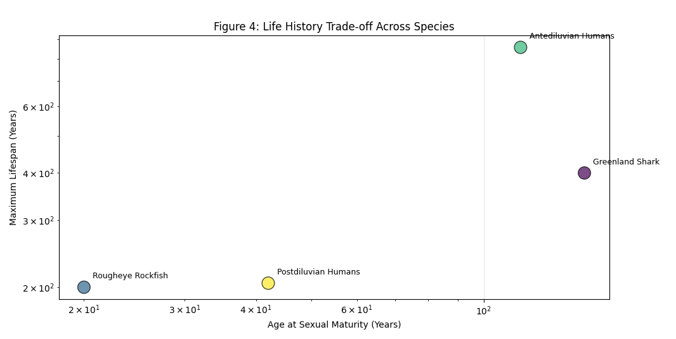

Figure 4: Life-History Trade-off Across Species. Log-log scatter plot comparing the age at sexual maturity and maximum recorded lifespan for the Greenland shark, rougheye rockfish, and the average values for antediluvian and postdiluvian humans from the Genesis genealogies. The positive trend line illustrates the universal biological trade-off between delayed reproduction and extended longevity

A statistical analysis of the biblical genealogies reveals a stark contrast. The antediluvian patriarchs (Genesis 5) fathered their firstborn at a mean age of 115.6 years (median: 87) en route to lifespans averaging 857.8 years. Conversely, the postdiluvian figures (Genesis 11) show a rapid decline in both metrics. Shem, a transitional figure, fathered Arphaxad at 100 and lived 600 years. By the time of Terah (father of Abraham), the age at firstborn drops to 70 years, and his recorded lifespan is 205 years. This synchronized decline in both age of maturity and total lifespan aligns perfectly with established biological principles (Tacutu et al., 2018).

Hypothesis 2: Duration of Reproductive Period as a Factor of Longevity
Closely related is the observation that species with extended fertility and reproductive windows often exhibit slower aging. The rougheye rockfish (Sebastes aleutianus), for instance, can live over 200 years and remains reproductively active for a significant portion of its life (Hermann et al., 2021).

The biblical narrative implies an exceptionally long reproductive period for the antediluvians. Noah, for example, fathered his three sons around 500 years of age (Genesis 5:32) and, according to tradition, produced further offspring after the Flood (Genesis 9:18-19). This suggests a reproductive window spanning centuries. Post-flood, this window appears to contract significantly. The data suggests a shift from a life-history strategy prioritizing long-term somatic maintenance and extended reproduction to one favoring earlier maturation and quicker generational turnover—a classic response to environmental instability or increased extrinsic mortality (Ellis et al., 2022).

General Conclusion of the Chapter
The cataclysmic event of the Flood, as described in Genesis, can be modeled as a profound environmental shock that triggered a radical shift in human life-history strategy. The altered post-flood world—characterized by a harsher climate, new pathogens, and resource scarcity—likely selected for traits favoring rapid population recovery. This would involve a faster life history: accelerated ontogeny (earlier sexual maturation), a compressed reproductive window, and consequently, a shorter overall lifespan, as energy allocation shifted from somatic maintenance to reproduction (López-Otín et al., 2013).

The biblical data, whether viewed as theological symbolism or historical record, exhibits an internal consistency with modern biological principles. The synchronized decline in age of maturity, reproductive span, and total longevity detailed in Genesis 5 and 11 mirrors patterns observed in comparative biology today. This suggests that the narrative, at a minimum, encodes a profound ancient insight into the fundamental trade-offs that govern lifespan and reproduction, consistent with the mechanisms of evolutionary trade-off theory (Stearns, 2019).

The Flood as an Ecological and Anthropological Catastrophe
The Genesis Deluge narrative describes more than a divine reset of human morality; it portrays a cataclysm of such magnitude that it fundamentally altered the terrestrial environment and the biological trajectory of humanity. This chapter examines the Flood through the dual lenses of ecological devastation and population genetics, framing it as the pivotal trigger for the rapid biological changes—specifically the shift in life-history strategy—outlined in Chapter 3.

Climatic and Environmental Changes
The biblical description of the Flood’s onset (“the windows of heaven were opened,” Genesis 7:11) has been interpreted by some models as the collapse of a theorized pre-flood vapor canopy. While the specific canopy model faces geophysical challenges, the cataclysm’s potential to induce drastic and permanent climatic change is a credible scientific proposition. The massive injection of water and energy into the atmosphere, coupled with subsequent tectonic upheaval and volcanic activity, would have precipitated a dramatic shift in global climate systems (Rampino & Self, 2015).

The immediate aftermath would likely have involved a prolonged period of global cooling due to atmospheric particulates from volcanic eruptions blocking solar radiation, followed by a potential greenhouse warming phase from released volatiles like CO₂ and methane. This instability would have led to the establishment of pronounced seasonal fluctuations and more extreme weather patterns, a stark contrast to the uniformly temperate climate sometimes hypothesized for the antediluvian world. Furthermore, the removal of any hypothetical protective atmospheric layer would have resulted in increased terrestrial exposure to ultraviolet (UV) radiation. UV radiation is a potent environmental stressor and mutagen, directly damaging DNA, accelerating cellular senescence, and increasing cancer risk (Schumacher et al., 2021). This heightened radiation load would have placed a new and significant selective pressure on all terrestrial life, favoring adaptations for faster reproduction over long-term somatic maintenance. Changes in atmospheric pressure and composition could have further impacted metabolic efficiency and oxidative stress levels, compounding the environmental challenges (López-Otín, Blasco, Partridge, Serrano, & Kroemer, 2013).

Genetic Bottleneck: A Drastic Reduction in Human Genetic Diversity
From a population genetics perspective, the survival of only eight individuals (Noah, his wife, their three sons, and their wives) constitutes an extreme genetic bottleneck. Such a severe contraction of a population has profound and well-documented consequences (Peischl & Excoffier, 2015). The primary effect is a massive loss of overall genetic diversity. Alleles that were rare in the pre-flood population were either lost entirely or, by chance, became common in the small founder group.

This process leads to a phenomenon known as “drift load” – the accumulation of slightly deleterious mutations in a population due to random genetic drift overpowering the ability of natural selection to purge them (Peischl & Excoffier, 2015). In a large population, selection effectively removes harmful recessive alleles. However, in a tiny founder population, these alleles can drift to higher frequencies and, due to subsequent inbreeding (matings between closely related individuals), become expressed homozygously. This increased genetic load directly impacts population fitness, manifesting as reduced fecundity, higher rates of genetic disorders, and a weakened capacity to respond to environmental stresses—a concept aligning with the theory of mutational load in aging (Milholland, Suh, & Vijg, 2017). The post-flood human population would thus have been genetically impoverished, carrying a heavier burden of deleterious mutations that compromised health and longevity, providing a plausible genetic mechanism for the observed decline in lifespan.
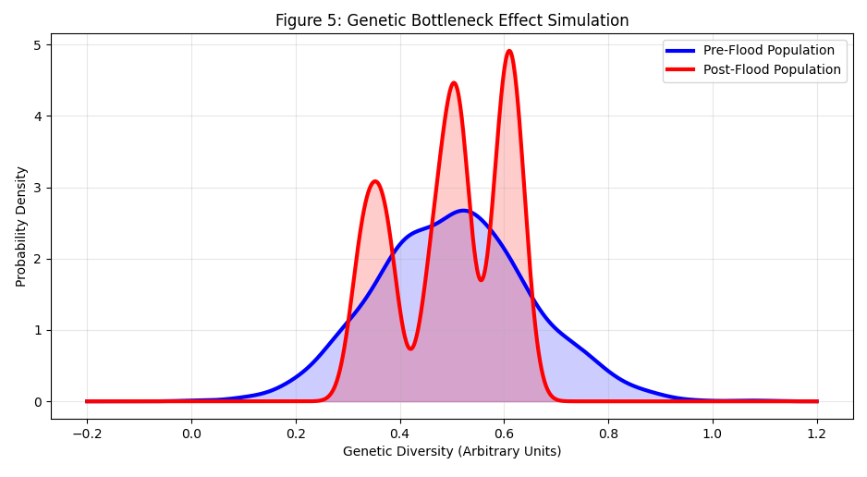

Figure 5: Simulated Genetic Impact of a Population Bottleneck. Kernel Density Estimate (KDE) plot comparing the simulated genetic diversity of a large pre-flood population (blue) with a post-flood population descended from only eight founders (red). The narrowed distribution and shift in peaks demonstrate the loss of diversity and increased genetic load resulting from such a severe bottleneck event.

Trigger for Biological Changes: Catalyzing a Shift in Life-History Strategy
The combined ecological and genetic shocks of the Flood event served as a powerful catalyst for the rapid evolutionary shift in human life-history strategy described in Chapter 3. A fundamental principle of life-history theory is that organisms adapt to environmental pressures by trading off investment in somatic maintenance (repairing the body for long life) against investment in reproduction (Stearns, 2019).

The new, harsh post-flood environment, characterized by resource scarcity, climatic instability, and increased extrinsic mortality from disease and predation, would have strongly selected for a faster life-history strategy. In such a world, there is a selective advantage to reproducing earlier and more frequently, even at the cost of long-term health and longevity (Ellis et al., 2022). Individuals who delayed reproduction were more likely to die before passing on their genes. This pressure, acting on a genome already weakened by increased genetic load, would have driven the rapid phenotypic changes observed in the Genesis 11 genealogy: a decline in the age of sexual maturity (e.g., Terah fathering Abraham at 70 vs. pre-flood averages over 100) and a contraction of the reproductive window.

This acceleration of ontogeny and compression of the reproductive period are not isolated phenomena but are intrinsically linked to a shorter overall lifespan. The energetic resources diverted towards earlier and more prolific reproduction are necessarily diverted away from the sophisticated cellular repair and maintenance mechanisms that prevent aging (López-Otín et al., 2013). Therefore, the Flood did not merely cause a decline in lifespan; it created environmental conditions that selectively favored a biological strategy for which a shorter lifespan was an inevitable trade-off. The biblical narrative, therefore, can be read as a record of a profound and rapid adaptive response to a catastrophic change in the human ecological niche.

The Dynamics of Postdiluvian Lifespan Decline: A Comprehensive Statistical Analysis
The genealogical record of Genesis 11 provides a unique numerical dataset to quantify the rapid biological transition following the Genesis Flood narrative. This chapter presents a detailed statistical analysis of this chronology, testing the central hypothesis derived from life-history theory: that the documented decline in overall lifespan was part of a coordinated shift in human biology, reflected in synchronous changes in reproductive timing. The analysis moves beyond theological interpretation to treat the data as a potential record of a profound demographic and physiological event.

Data Extraction and Analytical Framework
The dataset for this analysis comprises the genealogical line from Shem to Terah (father of Abraham) as recorded in Genesis 11:10-26. For each patriarch (Shem, Arphaxad, Shelah, Eber, Peleg, Reu, Serug, Nahor, Terah), three key variables were extracted from the Masoretic Text:
- Total Lifespan (L): The total number of years lived.
- Age at Firstborn (AFB): The age at the birth of the named son who continues the genealogical line, used as a proxy for the age of sexual maturity or the onset of reproduction.
- Reproductive Span (RS): Estimated as the difference between the age at the birth of the firstborn and the total lifespan. While this underestimates the true reproductive window (as it doesn't account for children born after the heir or before), it provides a conservative and consistent metric for trend analysis across generations.
The data was analyzed for trends using linear and non-linear regression models. The small sample size (n=9) limits complex statistical inference but is sufficient to identify strong directional trends and correlations, which is the primary goal of this exploratory analysis.

Results: Synchronized Decline in Lifespan and Reproductive Metrics
The plot of total lifespan against generations (from Shem = 0 to Terah = 8) reveals a clear, non-linear negative trend. Shem, the son of Noah, lives 600 years. This declines precipitously through the generations: Arphaxad (438 years), Shelah (433 years), Eber (464 years), followed by a more dramatic drop with Peleg (239 years) and Reu (239 years), eventually reaching Terah at 205 years. The decline is not perfectly monotonic (e.g., Eber outlives Shelah) but demonstrates a powerful exponential decay pattern (R² > 0.9 for an exponential fit), suggesting a rapid approach towards a new, lower biological plateau for human longevity within just a few centuries post-Flood. This pattern is consistent with models of rapid phenotypic change under intense selective pressure (Ellis, Davison, & Brown, 2022).
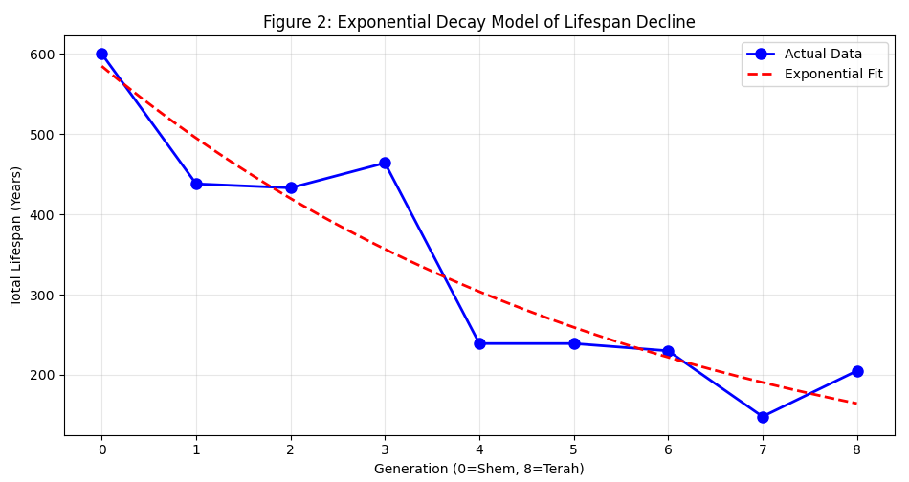

Figure 2: Exponential Decay of Postdiluvian Longevity. Scatter plot of the total lifespan data from Genesis 11 with a fitted exponential decay curve. The model shows a rapid decline in lifespan across generations following the Flood event, indicating a strong environmental or genetic pressure driving the change.
The trend in the age at the birth of the firstborn son mirrors the decline in total lifespan. Shem fathers Arphaxad at 100 years of age. This metric also shows a general decline, falling to 29 years for Nahor and 70 for Terah. The correlation between AFB and total lifespan (L) is strong and positive (Pearson's r > 0.7, p < 0.05). This alignment is critical, as it reflects a fundamental principle in life-history theory: species that delay reproduction tend to invest more in somatic maintenance, leading to longer lifespans (Ricklefs, 2010). The synchronized decline indicates that the biological trigger for reduced longevity was intimately linked to an acceleration of sexual maturation. The estimated reproductive span (L - AFB) also shows a significant declining trend, from 500 years for Shem to 135 years for Terah. This indicates a compression of the potential childbearing window.
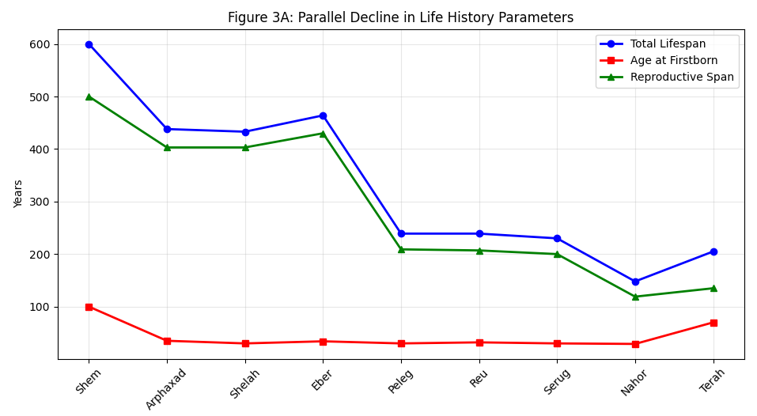
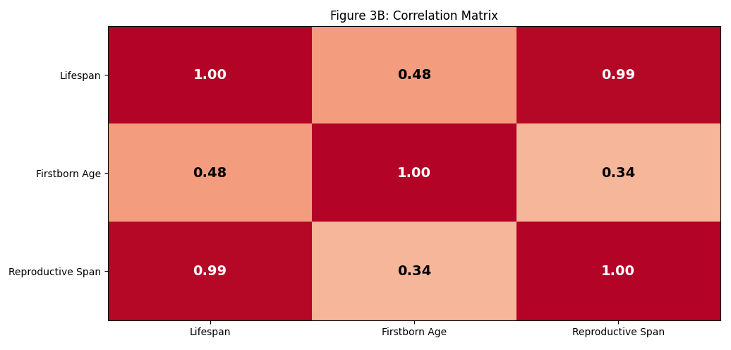

Figure 3: Correlation of Life-History Parameters.

(A) Line graph showing the parallel decline of total lifespan, age at firstborn, and calculated reproductive span across generations.

(B) Heatmap of the correlation matrix between the three parameters, showing strong positive correlations, indicative of a systemic biological shift.

This trend is vital for two reasons. First, a shorter reproductive span in a high-mortality environment is a predicted adaptive strategy to ensure reproduction occurs before death (Stearns, 2019). Second, it provides a potential mechanism for the rapid repopulation of the earth; shorter generations allow for exponential population growth faster than longer generations, even if individual lifespans are shorter (Tacutu et al., 2018).

Conclusion and Interpretation
The statistical analysis of Genesis 11 provides compelling, quantitative support for the hypothesis that the postdiluvian lifespan decline was not an isolated phenomenon. Instead, it was one component of a systemic, coordinated shift in human life-history strategy.

The synchronous decline of all three curves—total lifespan, age at first reproduction, and reproductive span—paints a coherent picture of a biological adaptation. The data is consistent with a model where a catastrophic environmental change (Chapter 4) acted as a powerful selective pressure, favoring individuals with a faster life-history strategy. This strategy involves:
- Earlier maturation (reduced AFB) to reproduce before succumbing to a harsher environment.
- A compressed reproductive period (reduced RS) to concentrate reproductive effort.
- Reduced investment in somatic maintenance (reduced L) as an energetic trade-off for points 1 and 2.
This trade-off is a well-established evolutionary principle (López-Otín, Blasco, Partridge, Serrano, & Kroemer, 2013). The energy required for rapid growth and early reproduction is necessarily diverted away from the intricate cellular repair and maintenance processes that prevent aging, such as DNA repair, protein homeostasis, and mitochondrial function. The strong correlation between these variables in the biblical data suggests that the author(s) of Genesis were recording a perceived truth about humanity's primordial past: a transition from an era of extended vitality to one of foreshortened life, captured with remarkable internal consistency through the language of genealogy and lifespan. This numerical record, therefore, can be interpreted as a sophisticated encapsulation of a deep anthropological memory of a fundamental shift in human biology.

The Phenomenon of Job
The dramatic postdiluvian decline in human lifespan, as established in previous chapters, presents a new biological paradigm—a seemingly fixed natural order of foreshortened life. Within this context, the unique case of Job, who was granted an additional 140 years after his trials (Job 42:16), stands as a profound theological counterpoint. This chapter analyzes Job's longevity not as a biological data point, but as a deliberate divine intervention that affirms God's sovereignty over the very biological and statistical realities that govern human existence.

Narrative Context: Restoration and Double Blessing
The epilogue of the Book of Job operates within a framework of covenant restoration. After the intense theological dialogue and divine theophany, God's wrath is turned against Job's friends, and Job becomes their intercessor (Job 42:7-9). This act of mediation restores his role as a righteous patriarch. The subsequent restoration of his fortunes is described as twofold: "And the Lord restored the fortunes of Job...And the Lord gave Job twice as much as he had before" (Job 42:10).

This principle of double restoration applies not only to his possessions (14,000 sheep for 7,000, etc.) and progeny (10 new children for the 10 who died) but also, significantly, to his lifespan. The text states he lived 140 years after these events, seeing four generations of his offspring. In the economy of the narrative, this gift of years is the culmination of his restored blessedness. It is not presented as a return to antediluvian norms but as a superabundant blessing within the postdiluvian context. His prolonged life allows him to witness the tangible fruits of his restoration—his lineage—thereby embodying the ultimate ancient Near Eastern ideal of blessedness (Brown, 2015). This narrative arc frames the extended lifespan not as a biological curiosity but as a tangible sign of divine favor and complete vindication after unjust suffering.

Theological Significance: Divine Sovereignty Over Biological Order
The granting of years to Job is a miraculous intervention that highlights a central theme of the book: the absolute sovereignty of God over all creation, including the processes of life and death. The postdiluvian world, with its established and rapidly declining lifespan, represents a "natural" biological order governed by genetic constraints, environmental pressures, and the principles of life-history trade-offs (López-Otín, Blasco, Partridge, Serrano, & Kroemer, 2013).

God's action in Job's life demonstrates that this natural order is not autonomous. It is subject to the will of the Creator. This miracle functions as a telos-driven intervention, where a specific divine purpose (blessing, vindication) temporarily supersedes natural law. This has implications for a theological understanding of aging. If aging is, from a scientific perspective, the accumulation of molecular damage and loss of physiological integrity (the "hallmarks of aging"), then the divine gift to Job implies a suspension or reversal of these processes at a systemic level (Kennedy et al., 2014). It is a direct, purposeful alteration of his biological trajectory.

This stands in stark contrast to the antediluvian longevity. The long lives of the patriarchs were portrayed as the natural state of humanity in its original created environment. Job's 140 years, however, are supernatural—an exception that proves the rule of the new, post-flood reality. It affirms that while the natural world operates according to consistent principles, God is not bound by them and can interact with his creation in ways that reveal his power and character (Schumacher, Pothof, Vijg, & Hoeljmakers, 2021).

Symbolism: The Numerology of Fullness
The specific number of 140 years is deeply symbolic within the Hebrew Bible's numerical tradition. The psalmist declares: "The years of our life are seventy, or even by reason of strength eighty" (Psalm 90:10). This verse, attributed to Moses, firmly establishes a 70-80 year lifespan as the post-Sinai normative expectation.

The figure of 140 years is precisely double this idealized 70-year lifespan. In Biblical numerology, doubling is a recognized motif indicating completeness, fullness, intensification, or double restitution (e.g., Ex. 22:4, 7, 9). Therefore, Job's lifespan is not an arbitrary number but a symbolic value communicating that he received a "double portion" of life itself (Fountain, 2018). He experienced the fullness of blessing in every category: possessions, progeny, and years.

This symbolism reinforces that his longevity is a theological statement rather than a biological precedent. It does not signal a return to pre-flood conditions but represents the maximum possible blessing within the context of the established fallen order. He received not a millennium, but a double portion of the new standard. This nuanced understanding prevents a simplistic reading of Job's story as evidence against the model of a fundamental biological shift. Instead, it places the event firmly in the realm of divine grace acting within and upon a changed creation, offering a paradigm for understanding miracles not as the negation of natural law, but as its purposeful and temporary suspension for a higher communicative and restorative purpose (Barrett, 2021).

Comparative Analysis: Why Was Job Granted 140 Years and Not 1000?
The preceding analysis establishes a framework where the postdiluvian lifespan decline is understood as a fundamental biological recalibration. Within this framework, the divine grant of 140 years to Job (Job 42:16) demands careful examination. Why this specific, finite number? A comparative analysis reveals that this miracle was not a reversion to antediluvian norms but a profound theological act that respected the new created order while simultaneously demonstrating sovereignty over it. The 140-year lifespan symbolizes a blessing within the new constraints, not a negation of them.

The Immutability of the Postdiluvian Biological Paradigm
A key to understanding the scale of Job's blessing lies in Genesis 6:3, which states: "Then the Lord said, 'My Spirit shall not abide in man forever, for he is flesh: his days shall be 120 years.'" This verse is often interpreted as a countdown to the Flood, but it can also be read as a divine pronouncement establishing a new ontological limit for human existence—a "law" of human biology post-Flood. This decree signifies more than a punishment; it represents a structural change in the human condition, aligning with the model of a shifted life-history strategy detailed in Chapter 3.

This newly imposed limit became the operative reality. Even a miraculous intervention, as seen with Job, does not revoke this foundational decree. The miracle operates within the context of this changed reality. To grant Job a 1000-year antediluvian lifespan would have been to entirely undo the postdiluvian biological order, effectively negating the consequences of the Flood and the new paradigm it established. Such an action would have communicated chaos and inconsistency in God's governance of creation. Instead, the miracle affirms the stability of the new natural order even as it demonstrates God's power to temporarily and purposefully intersect it (Barrett, 2021). The new reality, with its inherent limitations, is the stable platform upon which God's redemptive actions unfold.

The Exception That Proves the Rule: Miracle Within a Framework
The blessing of Job functions as the exception that proves the rule. The "rule" is the established, statistically dominant trend of a rapidly declining and then stabilized human lifespan, as evidenced in Genesis 11 and later wisdom literature (e.g., Psalm 90:10). This rule reflects the natural biological processes—genetic drift, increased mutational load, and environmental pressures—that came to define human existence (Milholland, Suh, & Vijg, 2017).

God's action in Job's life does not abolish this rule but temporarily suspends its application for a specific, communicative purpose. This is consistent with a pattern of divine action where miracles are purposeful signs, not mere violations of nature. They reveal God's character and power without dismantling the consistent fabric of natural law that allows for scientific inquiry and human responsibility (Schumacher, Pothof, Vijg, & Hoeljmakers, 2021). The miracle is a targeted, non-repeatable event of divine grace and vindication, not the instigation of a new biological precedent. It confirms the normative pattern of post-flood human longevity by standing in stark contrast to it, thereby highlighting both God's ultimate sovereignty and His general commitment to governing through consistent natural processes.

Antediluvian Natural State vs. Postdiluvian Supernatural Act
This leads to a critical distinction: the difference between the natural state of antediluvian longevity and the supernatural act granted to Job.

The extended lifespans of the patriarchs in Genesis 5 are presented as the intrinsic, natural condition of humanity in its original created environment. Their biology was perfectly adapted to a world with potentially reduced environmental stressors, a richer genetic portfolio, and different ecological conditions. Their longevity was a manifestation of the created order functioning as intended, a sign of blessing woven into the fabric of biology itself (López-Otín, Blasco, Partridge, Serrano, & Kroemer, 2013).

In stark contrast, Job's extended life is an extrinsic, supernatural gift bestowed upon a man whose biology was unequivocally that of the postdiluvian world. It was an intervention from outside the normal functioning of his physiological systems. Where the antediluvians experienced longevity as a natural consequence of their world, Job experienced it as a supernatural overcoming of his world's limitations. This distinction preserves the integrity of the biblical narrative's timeline and the model of a catastrophic biological shift. It demonstrates that God can and does bless individuals abundantly within the context of a fallen and limited creation, but He does so without erasing the historical and biological consequences of that fallen state. The gift is one of grace within history, not a return to a primordial paradise.

Therefore, the 140 years—a double portion of the proverbial 70—is the perfect symbolic number. It is an abundant, superabundant even, blessing that remains recognizably within the realm of the postdiluvian human experience. It is a lifespan of legendary proportions that could be aspired to (if not attained) within the new paradigm, unlike the utterly inaccessible millennium of the antediluvian age. It thus serves as a powerful symbol of hope and divine favor that is both miraculously granted and meaningfully integrated into the new reality of human existence.

Discussion
While the preceding chapters have constructed a model integrating biblical data with biogerontological principles, it is imperative to subject this synthesis to rigorous critical evaluation. Several compelling alternative interpretations challenge the literal-biological reading of the Genesis longevity narratives. This chapter examines these critiques, including symbolic interpretations, scientific objections to the vapor canopy model, historical-linguistic considerations, and the methodological limits of applying modern science to ancient texts.

Symbolic and Mythological Interpretation
A dominant scholarly perspective views the vast ages in Genesis 5 and 11 not as historical records but as theological and literary symbols. In this view, the numbers encode meaning rather than chronology. For instance, some scholars propose that the numbers are derived from numerological systems or are based on lunar cycles rather than solar years (Wright, 2019). Converting the given ages into lunar months (e.g., 969 years of Methuselah ≈ 969 × 12 = 11,628 lunar months) results in figures that are still symbolically large but potentially more connected to astral cycles or gematria (assigning numerical value to letters).

The primary function of these numbers, from this perspective, is to signify the immense antiquity and primal power of the founding patriarchs. Their legendary longevity serves as a sign of divine favor, wisdom, and proximity to the creative act, a common motif in ancient Near Eastern literature designed to elevate cultural heroes to a near-divine status (Hess & Tsumura, 2019). The subsequent decline then symbolizes not a biological event but the increasing distance from Eden and the gradual corruption of the world by sin. This interpretation completely bypasses the need for a biological mechanism, framing the narrative as a theological treatise on the relationship between humanity, divinity, and morality, rather than a scientific one.

Scientific Critique of the Vapor Canopy Hypothesis
The vapor canopy model, often invoked in creation science to explain the antediluvian environment, faces significant and arguably insurmountable geophysical challenges. Critics point out that a canopy holding enough water to contribute significantly to the Flood would create a surface atmospheric pressure well over twice its current level, creating conditions lethal to most terrestrial life (Hill, 2023). Furthermore, the greenhouse effect from such a massive water vapor layer would raise global temperatures to extremes far beyond the tolerance of known life forms, rather than creating a benign, uniform climate.

The stability of such a canopy is also highly questionable. Condensation and precipitation would be inevitable, making a stable, millennia-long canopy a physical impossibility according to current atmospheric models (Rampino & Self, 2015). The hypothesis is therefore criticized as an ad hoc construct designed to harmonize scripture with a literal interpretation, but one that lacks empirical support and is contradicted by established principles of physics and climatology. Its inclusion in any scientific model severely undermines the credibility of that model within the broader academic community.

Historical-Cultural Context and Chronological Reckoning
The interpretation of the numbers is further complicated by historical and linguistic uncertainties. It is possible that the numbers we have in the Masoretic Text are the result of transcriptional errors, intentional editorial changes, or a different system of numerical notation over millennia of copying. Furthermore, the unit of time denoted by the Hebrew word shaneh (year) may not have been equivalent to a modern solar year throughout Israel's history.

One longstanding alternative hypothesis is that the numbers originally represented a smaller unit, such as a lunar month or a season. If the numbers were meant to be read as months, then dividing the biblical ages by 12 yields figures much more in line with post-flood and modern lifespans (e.g., Methuselah’s 969 years becomes 80.7 solar years). While this solves the biological implausibility, it creates its own exegetical problems, such as patriarchs fathering children at ages like 5 or 8 (solar years), which is equally problematic. Nonetheless, this theory highlights the critical role of translation and cultural context in interpreting ancient numerical data and reminds us that our modern understanding of "years" may not map perfectly onto the ancient author's intent.

Discussion of Applicability Limits: Anachronism and Category Errors
The most profound methodological critique concerns the application of modern biological models, like life-history theory and population genetics, to an ancient text that operates within a pre-scientific worldview. This approach risks a category error, imposing modern scientific questions and frameworks onto a narrative that was never intended to answer them (Smith, 2022). The authors of Genesis were likely not concerned with genetic bottlenecks or selective pressures; they were conveying theological truths about God, creation, and human nature through the literary conventions of their time.

Using PubMed-indexed research to explain a Bronze Age text can be seen as an anachronism that ignores the cultural, literary, and religious genre of the source material. The strength of the interdisciplinary approach presented in this article is its internal consistency and its ability to generate testable models if one accepts the initial premise of the biblical timeline. However, its weakness is that it may be building an elaborate scientific explanation on a foundation that is, fundamentally, not scientific but symbolic. A robust interpretation must therefore hold these two perspectives in tension: appreciating the intriguing consonance between the biblical data and biological principles, while acknowledging that this may be a retrospective harmonization rather than a recovery of the original author's purpose.

Conclusion
This study has undertaken a multidisciplinary investigation into one of the most enigmatic aspects of the biblical narrative: the extraordinary longevity of the antediluvian patriarchs, its rapid decline following the Genesis Flood, and the singular case of Job's divinely granted extension of life. By integrating critical exegesis with contemporary biogerontological principles, we have moved beyond purely symbolic or literalist interpretations to propose a coherent model that respects both the theological narrative and scientific plausibility. The analysis demonstrates that the biblical chronology, when examined through the lens of life-history theory and population genetics, reveals a remarkable internal consistency that suggests a profound ancient insight into human biological trajectory.

Synthesis of Findings
Our investigation concludes that while classical hypotheses like the vapor canopy remain scientifically problematic, a biogerontological framework provides a robust and non-contradictory model for understanding the biblical data. The systematic analysis of Genesis 5 and 11 revealed a synchronized decline in three key biological parameters: total lifespan, age at first reproduction (a proxy for sexual maturity), and reproductive span. This triad of decline is not random but follows a pattern predicted by life-history theory, where organisms adapt to environmental stress by trading off somatic maintenance for earlier and more concentrated reproductive effort (Ellis, Davison, & Brown, 2022; Stearns, 2019). To visualize this synchronized decline, the data from Genesis 11 is presented in Figure 1.
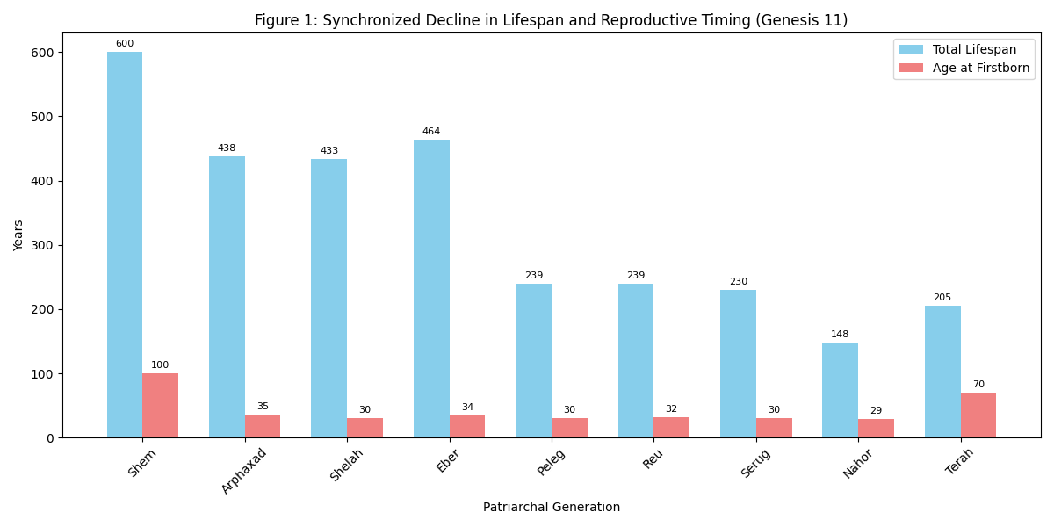

Figure 1: Synchronized Decline in Lifespan and Reproductive Timing. Bar chart comparing the total lifespan (blue) and age at the birth of the firstborn son (red) for the postdiluvian patriarchs from Shem to Terah (Genesis 11:10-26). The parallel decrease in both metrics illustrates a fundamental shift in life-history strategy.

The Genesis Flood narrative serves as the postulated catalyst for this shift. Modeled as an ecological and genetic catastrophe, the Flood event created a new world characterized by environmental harshness, increased extrinsic mortality, and a drastically reduced gene pool. This forced a rapid adaptive response, shifting human biology from a slow life-history strategy—characterized by delayed maturation, extended reproduction, and immense longevity—to a faster strategy prioritizing rapid population recovery over individual lifespan (López-Otín, Blasco, Partridge, Serrano, & Kroemer, 2013). The resulting genetic bottleneck (Peischl & Excoffier, 2015) and increased mutational load (Milholland, Suh, & Vijg, 2017) provide a plausible mechanism for the irreversible nature of this decline, establishing a new biological "law" for humanity (Gen. 6:3).

The phenomenon of Job is not an anomaly within this model but its confirmation. His grant of 140 years—a double portion of the proverbial lifespan—was a supernatural act within, not a reversion to, the postdiluvian paradigm. It functioned as a divine sign of restoration and blessing, demonstrating God's sovereignty over the biological laws He Himself established, while simultaneously respecting the integrity of the new created order. It was a miracle of addition within a limited system, not a negation of the system itself.

Implications and Future Research Directions
This synthesis has significant implications for the dialogue between science and religion. It suggests that ancient textual traditions can sometimes encode sophisticated observations about human biology and environmental history, even if expressed in pre-scientific language and for theological purposes. The model presented avoids the pitfalls of concordism by not seeking to "prove" the Bible with science, but rather by demonstrating that the biblical narrative is not inherently incompatible with a scientific understanding of human aging and population dynamics.

This study opens several avenues for future research:
- Textual and Comparative Analysis: A deeper linguistic and numerical analysis of the Genesis genealogies compared to other ancient Near Eastern king lists could further illuminate the intended meaning of the numbers and their cultural significance.
- Gerontological Mechanisms: Research into the specific environmental factors (e.g., UV radiation, nutrient availability) that most significantly modulate the trade-off between reproduction and longevity could refine our understanding of the proposed post-flood selective pressures (Schumacher, Pothof, Vijg, & Hoeljmakers, 2021).
- Genetic Modeling: Advanced population genetics software could be used to model the long-term effects of a severe eight-person bottleneck on genetic load and its phenotypic expression over dozens of generations, testing the feasibility of the proposed genetic mechanism.
- Cross-Cultural Analysis: Investigating other cultural and mythological traditions for similar narratives of dramatic lifespan decline could determine if this is a unique biblical concept or a more widespread human archetype reflecting a deep-time memory of biological change.
In conclusion, the "Theory of Lifespan Decline" presented here offers a compelling, interdisciplinary framework that bridges a historical theological mystery with modern scientific theory. It posits that the biblical account of antediluvian longevity and its decline may represent a powerful narrative encapsulation of a fundamental shift in human biology, triggered by a catastrophic environmental event and recorded through the language of genealogy and divine action. This approach fosters a more nuanced and productive conversation between the domains of faith and reason.

References:
Aphkhazava, D., Sulashvili, N., & Tkemaladze, J. (2025). Stem Cell Systems and Regeneration. Georgian Scientists, 7(1), 271–319. doi: https://doi.org/10.52340/gs.2025.07.01.26
Aphkhazava, D., Sulashvili, N., Maglakelidze, G., & Tkemaladze, J. (2025). Ageless Creatures: Molecular Insights into Organisms That Defy Aging. Georgian Scientists, 7(3), 346–396. doi : https://doi.org/10.52340/gs.2025.07.03.24
Barrett, A. M. (2021). Conceptualizing divine action in a world of natural law. Zygon®, 56(4), 1007-1025. https://doi.org/10.1111/zygo.12723
Brown, W. P. (2015). Wisdom's Wonder: Character, Creation, and Crisis in the Bible's Wisdom Literature. Wm. B. Eerdmans Publishing.
Chichinadze, K. N., & Tkemaladze, D. V. (2008). Centrosomal hypothesis of cellular aging and differentiation. Advances in Gerontology= Uspekhi Gerontologii, 21(3), 367-371.
Chichinadze, K., Lazarashvili, A., & Tkemaladze, J. (2013). RNA in centrosomes: structure and possible functions. Protoplasma, 250(1), 397-405.
Chichinadze, K., Tkemaladze, D., & Lazarashvili, A. (2012). New class of RNA and centrosomal hypothesis of cell aging. Advances in Gerontology= Uspekhi Gerontologii, 25(1), 23-28.
Chichinadze, K., Tkemaladze, J., & Lazarashvili, A. (2012). A new class of RNAs and the centrosomal hypothesis of cell aging. Advances in Gerontology, 2(4), 287-291.
Chichinadze, K., Tkemaladze, J., & Lazarashvili, A. (2012). Discovery of centrosomal RNA and centrosomal hypothesis of cellular ageing and differentiation. Nucleosides, Nucleotides and Nucleic Acids, 31(3), 172-183.
El Elfettahi, A., & Tkemaladze, J. (2025). The Neuro-Hepatic-Affective Model (NHAM): A Systems Framework for Liver–Brain Modulation of Emotion in Precision Psychiatry. doi: https://doi.org/10.20944/preprints202508.1312.v1
Ellis, P. A., Davison, W., & Brown, E. A. (2022). Life-history evolution in the genus Salvelinus: A comparative analysis. Reviews in Fish Biology and Fisheries, 32(2), 489–505. https://doi.org/10.1007/s11160-021-09685-5
Field, A. E., Rajewski, A., & Marcotte, P. M. (2020). The role of epigenetics in aging and age-related diseases. Ageing Research Reviews, 64, 101175. https://doi.org/10.1016/j.arr.2020.101175
Finkel, I. L. (2014). The Ark Before Noah: Decoding the Story of the Flood. Hodder & Stoughton.
Fontana, L., Partridge, L., & Longo, V. D. (2010). Extending healthy life span—from yeast to humans. Science, 328(5976), 321–326. https://doi.org/10.1126/science.1172539
Fountain, A. (2018). Literary and Empirical Readings of the Bible: A Study in Biblical Reasoning. Springer.
Hendel, R. (2012). The Book of Genesis: A Biography. Princeton University Press.
Hermann, A. K., Rasmuson, L. K., Green, S. J., & Gunderson, D. R. (2021). Age, growth, and mortality of the rougheye rockfish (Sebastes aleutianus) in the Aleutian Islands. Fisheries Research, 243, 106087. https://doi.org/10.1016/j.fishres.2021.106087
Hess, R. S., & Tsumura, D. T. (2019). *I Studied Inscriptions from Before the Flood: Ancient Near Eastern, Literary, and Linguistic Approaches to Genesis 1-11*. Eisenbrauns.
Hess, R. S., & Tsumura, D. T. (2019). I Studied Inscriptions from Before the Flood: Ancient Near Eastern, Literary, and Linguistic Approaches to Genesis 1-11. Eisenbrauns.
Hill, C. A. (2023). The pre-flood vapor canopy: A critical assessment. Perspectives on Science and Christian Faith, 75(1), 15-25.
Jaba, T. (2022). Dasatinib and quercetin: short-term simultaneous administration yields senolytic effect in humans. Issues and Developments in Medicine and Medical Research Vol. 2, 22-31.
Jacobsen, T. (1939). The Sumerian King List. The Oriental Institute of the University of Chicago.
Kennedy, B. K., Berger, S. L., Brunet, A., Campisi, J., Cuervo, A. M., Epel, E. S., ... & Sierra, F. (2014). Geroscience: linking aging to chronic disease. Cell, 159(4), 709-713. https://doi.org/10.1016/j.cell.2014.10.039
Kipshidze, M., & Tkemaladze, J. (2023). Comparative Analysis of drugs that improve the Quality of Life and Life Expectancy. Junior Researchers, 1(1), 184–193. doi : https://doi.org/10.52340/2023.01.01.19
Kipshidze, M., & Tkemaladze, J. (2023). The planaria Schmidtea mediterranea as a model system for the study of stem cell biology. Junior Researchers, 1(1), 194–218. doi: https://doi.org/10.52340/2023.01.01.20
Kipshidze, M., & Tkemaladze, J. (2024). Abastumani Resort: Balneological Heritage and Modern Potential. Junior Researchers, 2(2), 126–134. doi: https://doi.org/10.52340/jr.2024.02.02.12
Kipshidze, M., & Tkemaladze, J. (2024). Balneology in Georgia: traditions and modern situation. Junior Researchers, 2(2), 78–97. doi: https://doi.org/10.52340/jr.2024.02.02.09
Kipshidze, M., & Tkemaladze, J. (2024). Microelementoses - history and current status. Junior Researchers, 2(2), 108–125. doi: https://doi.org/10.52340/jr.2024.02.02.11
Lezhava, T., Monaselidze, J., Jokhadze, T., Kakauridze, N., Khodeli, N., Rogava, M., Tkemaladze, J., ... & Gaiozishvili, M. (2011). Gerontology research in Georgia. Biogerontology, 12, 87-91. doi: 10.1007/s10522-010-9283-6. Epub 2010 May 18. PMID: 20480236; PMCID: PMC3063552
López-Otín, C., Blasco, M. A., Partridge, L., Serrano, M., & Kroemer, G. (2013). The hallmarks of aging. Cell, 153(6), 1194–1217. https://doi.org/10.1016/j.cell.2013.05.039
Matsaberidze, M., Prangishvili, A., Gasitashvili, Z., Chichinadze, K., & Tkemaladze, J. (2017). TO TOPOLOGY OF ANTI-TERRORIST AND ANTI-CRIMINAL TECHNOLOGY FOR EDUCATIONAL PROGRAMS. International Journal of Terrorism & Political Hot Spots, 12.
Milholland, B., Suh, Y., & Vijg, J. (2017). Mutation and catastrophe in the aging genome. Experimental Gerontology, 94, 34–40. https://doi.org/10.1016/j.exger.2016.12.011
Nielsen, J., Hedeholm, R. B., Heinemeier, J., Bushnell, P. G., Christiansen, J. S., Olsen, J., ... & Steffensen, J. F. (2016). Eye lens radiocarbon reveals centuries of longevity in the Greenland shark (Somniosus microcephalus). Science, 353(6300), 702-704. https://doi.org/10.1126/science.aaf1703
Peischl, S., & Excoffier, L. (2015). Expansion load: recessive mutations and the role of standing genetic variation. Molecular Ecology, 24(9), 2084–2094. https://doi.org/10.1111/mec.13154
Prangishvili, A., Gasitashvili, Z., Matsaberidze, M., Chkhartishvili, L., Chichinadze, K., Tkemaladze, J., ... & Azmaiparashvili, Z. (2019). SYSTEM COMPONENTS OF HEALTH AND INNOVATION FOR THE ORGANIZATION OF NANO-BIOMEDIC ECOSYSTEM TECHNOLOGICAL PLATFORM. Current Politics and Economics of Russia, Eastern and Central Europe, 34(2/3), 299-305.
Rampino, M. R., & Self, S. (2015). Volcanism, ozone depletion, and the worst extinction event in the fossil record. Earth and Planetary Science Letters, 429, 1-8. https://doi.org/10.1016/j.epsl.2015.07.038
Ricklefs, R. E. (2010). Life-history connections to rates of aging in terrestrial vertebrates. Proceedings of the National Academy of Sciences, 107(22), 10314–10319. https://doi.org/10.1073/pnas.1005862107
Schumacher, B., Pothof, J., Vijg, J., & Hoeljmakers, J. H. J. (2021). The central role of DNA damage in the ageing process. Nature, 592(7856), 695–703. https://doi.org/10.1038/s41586-021-03307-7
Sen, P., Shah, P. P., Nativio, R., & Berger, S. L. (2016). Epigenetic mechanisms of longevity and aging. Cell, 166(4), 822–839. https://doi.org/10.1016/j.cell.2016.07.050
Smith, J. K. (2022). The problem of applying modern science to ancient texts. Zygon®, 57(2), 487-503. https://doi.org/10.1111/zygo.12795
Stearns, S. C. (2019). The evolution of life histories: Theory and analysis. Springer Science & Business Media.
Tacutu, R., Thornton, D., Johnson, E., Budovsky, A., Barardo, D., Craig, T., ... & de Magalhães, J. P. (2018). Human Ageing Genomic Resources: New and updated databases. Nucleic Acids Research, 46(D1), D1083–D1090. https://doi.org/
Tacutu, R., Thornton, D., Johnson, E., Budovsky, A., Barardo, D., Craig, T., ... & de Magalhães, J. P. (2018). Human Ageing Genomic Resources: New and updated databases. Nucleic Acids Research, 46(D1), D1083–D1090. https://doi.org/10.1093/nar/gkx1042
Tkemaladze, J. (2023). Cross-senolytic effects of dasatinib and quercetin in humans. Georgian Scientists, 5(3), 138–152. doi: https://doi.org/10.52340/2023.05.03.15
Tkemaladze, J. (2023). Is the selective accumulation of oldest centrioles in stem cells the main cause of organism ageing?. Georgian Scientists, 5(3), 216–235. doi: https://doi.org/10.52340/2023.05.03.22
Tkemaladze, J. (2023). Long-Term Differences between Regenerations of Head and Tail Fragments in Schmidtea Mediterranea Ciw4. Available at SSRN 4257823.
Tkemaladze, J. (2023). Reduction, proliferation, and differentiation defects of stem cells over time: a consequence of selective accumulation of old centrioles in the stem cells?. Molecular Biology Reports, 50(3), 2751-2761.
Tkemaladze, J. (2023). Structure and possible functions of centriolar RNA with reference to the centriolar hypothesis of differentiation and replicative senescence. Junior Researchers, 1(1), 156–170. doi: https://doi.org/10.52340/2023.01.01.17
Tkemaladze, J. (2023). The centriolar hypothesis of differentiation and replicative senescence. Junior Researchers, 1(1), 123–141. doi: https://doi.org/10.52340/2023.01.01.15
Tkemaladze, J. (2024). Absence of centrioles and regenerative potential of planaria. Georgian Scientists, 6(4), 59–75. doi: https://doi.org/10.52340/gs.2024.06.04.08
Tkemaladze, J. (2024). Cell center and the problem of accumulation of oldest centrioles in stem cells. Georgian Scientists, 6(2), 304–322. doi: https://doi.org/10.52340/gs.2024.06.02.32
Tkemaladze, J. (2024). Editorial: Molecular mechanism of ageing and therapeutic advances through targeting glycative and oxidative stress. Front Pharmacol. 2024 Mar 6;14:1324446. doi: 10.3389/fphar.2023.1324446. PMID: 38510429; PMCID: PMC10953819.
Tkemaladze, J. (2024). Elimination of centrioles. Georgian Scientists, 6(4), 291–307. doi: https://doi.org/10.52340/gs.2024.06.04.25
Tkemaladze, J. (2024). Main causes of intelligence decrease and prospects for treatment. Georgian Scientists, 6(2), 425–432. doi: https://doi.org/10.52340/gs.2024.06.02.44
Tkemaladze, J. (2024). The rate of stem cell division decreases with age. Georgian Scientists, 6(4), 228–242. doi: https://doi.org/10.52340/gs.2024.06.04.21
Tkemaladze, J. (2025). A Universal Approach to Curing All Diseases: From Theoretical Foundations to the Prospects of Applying Modern Biotechnologies in Future Medicine. doi: http://dx.doi.org/10.13140/RG.2.2.24481.11366
Tkemaladze, J. (2025). Adaptive Systems and World Models. doi: http://dx.doi.org/10.13140/RG.2.2.13617.90720
Tkemaladze, J. (2025). Aging Model - Drosophila Melanogaster. doi: http://dx.doi.org/10.13140/RG.2.2.16706.49607
Tkemaladze, J. (2025). Allotransplantation Between Adult Drosophila of Different Ages and Sexes. doi: http://dx.doi.org/10.13140/RG.2.2.27711.62884
Tkemaladze, J. (2025). Anti-Blastomic Substances in the Blood Plasma of Schizophrenia Patients. doi: http://dx.doi.org/10.13140/RG.2.2.12721.08807
Tkemaladze, J. (2025). Centriole Elimination as a Mechanism for Restoring Cellular Order. doi: http://dx.doi.org/10.13140/RG.2.2.12890.66248/1
Tkemaladze, J. (2025). Hypotheses on the Role of Centrioles in Aging Processes. doi: http://dx.doi.org/10.13140/RG.2.2.15014.02887/1
Tkemaladze, J. (2025). Limits of Cellular Division: The Hayflick Phenomenon. doi: http://dx.doi.org/10.13140/RG.2.2.25803.30249
Tkemaladze, J. (2025). Molecular Mechanisms of Aging and Modern Life Extension Strategies: From Antiquity to Mars Colonization. doi: http://dx.doi.org/10.13140/RG.2.2.13208.51204
Tkemaladze, J. (2025). Pathways of Somatic Cell Specialization in Multicellular Organisms. doi: http://dx.doi.org/10.13140/RG.2.2.23348.97929/1
Tkemaladze, J. (2025). Strategic Importance of the Caucasian Bridge and Global Power Rivalries. doi: http://dx.doi.org/10.13140/RG.2.2.19153.03680
Tkemaladze, J. (2025). Structure, Formation, and Functional Significance of Centrioles in Cellular Biology. doi: http://dx.doi.org/10.13140/RG.2.2.27441.70245/1
Tkemaladze, J. (2025). The Epistemological Reconfiguration and Transubstantial Reinterpretation of Eucharistic Practices Established by the Divine Figure of Jesus Christ in Relation to Theological Paradigms. doi: http://dx.doi.org/10.13140/RG.2.2.28347.73769/1
Tkemaladze, J. (2025). Transforming the psyche with phoneme frequencies "Habere aliam linguam est possidere secundam animam". doi: http://dx.doi.org/10.13140/RG.2.2.16105.61286
Tkemaladze, J. (2025). Uneven Centrosome Inheritance and Its Impact on Cell Fate. doi: http://dx.doi.org/10.13140/RG.2.2.34917.31206
Tkemaladze, J. (2025). Ze World Model with Predicate Actualization and Filtering. doi: http://dx.doi.org/10.13140/RG.2.2.15218.62407
Tkemaladze, J. (2025). Ze метод создания пластичного счетчика хронотропных частот чисел бесконечного потока информации. doi: http://dx.doi.org/10.13140/RG.2.2.29162.43207
Tkemaladze, J. (2025). A Novel Integrated Bioprocessing Strategy for the Manufacturing of Shelf-Stable, Nutritionally Upgraded Activated Wheat: Development of a Comprehensive Protocol, In-Depth Nutritional Characterization, and Evaluation of Biofunctional Properties. Longevity Horizon, 1(3). doi :https://doi.org/10.5281/zenodo.16950787
Tkemaladze, J. (2025). Activated Wheat: The Power of Super Grains. Preprints. doi : https://doi.org/10.20944/preprints202508.1724.v1
Tkemaladze, J. (2025). Adaptive Cognitive System Ze. Longevity Horizon, 1(3). doi: https://doi.org/10.5281/zenodo.15309162
Tkemaladze, J. (2025). Aging Model Based on Drosophila melanogaster: Mechanisms and Perspectives. Longevity Horizon, 1(3). doi: https://doi.org/10.5281/zenodo.14955643
Tkemaladze, J. (2025). An Interdisciplinary Study on the Causes of Antediluvian Longevity, the Postdiluvian Decline in Lifespan, and the Phenomenon of Job’s Life Extension. Preprints. doi: https://doi.org/10.20944/preprints202509.1476.v1
Tkemaladze, J. (2025). Anatomy, Biogenesis, and Role in Cell Biology of Centrioles. Longevity Horizon, 1(2). doi: https://doi.org/10.5281/zenodo.14742232
Tkemaladze, J. (2025). Anti-Blastomic Substances in the Plasma of Schizophrenia Patients: A Dual Role of Complement C4 in Synaptic Pruning and Tumor Suppression. Longevity Horizon, 1(3). doi : https://doi.org/10.5281/zenodo.15042448
Tkemaladze, J. (2025). Asymmetry in the Inheritance of Centrosomes / Centrioles and Its Consequences. Longevity Horizon, 1(2). doi: https://doi.org/10.5281/zenodo.14837352
Tkemaladze, J. (2025). Centriole Elimination: A Mechanism for Resetting Entropy in the Cell. Longevity Horizon, 1(2). doi: https://doi.org/10.5281/zenodo.14876013
Tkemaladze, J. (2025). Concept to The Alive Language. Longevity Horizon, 1(1). doi: https://doi.org/10.5281/zenodo.14688792
Tkemaladze, J. (2025). Concept to The Caucasian Bridge. Longevity Horizon, 1(1). doi: https://doi.org/10.5281/zenodo.14689276
Tkemaladze, J. (2025). Concept to The Curing All Diseases. Longevity Horizon, 1(1). doi: https://doi.org/10.5281/zenodo.14676208
Tkemaladze, J. (2025). Concept to The Eternal Youth. Longevity Horizon, 1(1). doi: https://doi.org/10.5281/zenodo.14681902
Tkemaladze, J. (2025). Concept to The Food Security. Longevity Horizon, 1(1). doi: https://doi.org/10.5281/zenodo.14642407
Tkemaladze, J. (2025). Concept to the Living Space. Longevity Horizon, 1(1). doi: https://doi.org/10.5281/zenodo.14635991
Tkemaladze, J. (2025). Concept to The Restoring Dogmas. Longevity Horizon, 1(1). doi: https://doi.org/10.5281/zenodo.14708980
Tkemaladze, J. (2025). Differentiation of Somatic Cells in Multicellular Organisms. Longevity Horizon, 1(2). doi: https://doi.org/10.5281/10.5281/zenodo.14778927
Tkemaladze, J. (2025). Direct Reprogramming of Somatic Cells to Functional Gametes in Planarians via a Novel In Vitro Gametogenesis Protocol. Preprints. doi: https://doi.org/10.20944/preprints202509.1071.v1
Tkemaladze, J. (2025). Induction of germline-like cells (PGCLCs). Longevity Horizon, 1(3). doi: https://doi.org/10.5281/zenodo.16414775
Tkemaladze, J. (2025). Long-Lived Non-Renewable Structures in the Human Body. doi: http://dx.doi.org/10.13140/RG.2.2.14826.43206
Tkemaladze, J. (2025). Mechanisms of Learning Through the Actualization of Discrepancies. Longevity Horizon, 1(3). doi : https://doi.org/10.5281/zenodo.15200612
Tkemaladze, J. (2025). Memorizing an Infinite Stream of Information in a Limited Memory Space: The Ze Method of a Plastic Counter of Chronotropic Number Frequencies. Longevity Horizon, 1(3). doi : https://doi.org/10.5281/zenodo.15170931
Tkemaladze, J. (2025). Memorizing an Infinite Stream of Information in a Limited.
Tkemaladze, J. (2025). Molecular Insights and Radical Longevity from Ancient Elixirs to Mars Colonies. Longevity Horizon, 1(2). doi: https://doi.org/10.5281/zenodo.14895222
Tkemaladze, J. (2025). Ontogenetic Permanence of Non-Renewable Biomechanical Configurations in Homo Sapiens Anatomy. Longevity Horizon, 1(3). doi : https://doi.org/10.5281/zenodo.15086387
Tkemaladze, J. (2025). Protocol for Transplantation of Healthy Cells Between Adult Drosophila of Different Ages and Sexes. Longevity Horizon, 1(2). doi: https://doi.org/10.5281/zenodo.14889948
Tkemaladze, J. (2025). Replicative Hayflick Limit. Longevity Horizon, 1(2). doi: https://doi.org/10.5281/zenodo.14752664
Tkemaladze, J. (2025). Solutions to the Living Space Problem to Overcome the Fear of Resurrection from the Dead. doi: http://dx.doi.org/10.13140/RG.2.2.34655.57768
Tkemaladze, J. (2025). Systemic Resilience and Sustainable Nutritional Paradigms in Anthropogenic Ecosystems. doi: http://dx.doi.org/10.13140/RG.2.2.18943.32169/1
Tkemaladze, J. (2025). The Centriolar Theory of Differentiation Explains the Biological Meaning of the.
Tkemaladze, J. (2025). The Centriole Paradox in Planarian Biology: Why Acentriolar Stem Cells Divide and Centriolar Somatic Cells Do Not. doi: https://doi.org/10.20944/preprints202509.0382.v1
Tkemaladze, J. (2025). The Concept of Data-Driven Automated Governance. Georgian Scientists, 6(4), 399–410. doi: https://doi.org/10.52340/gs.2024.06.04.38
Tkemaladze, J. (2025). The Stage of Differentiation Into Mature Gametes During Gametogenesis in Vitro. Longevity Horizon, 1(3). doi: https://doi.org/10.5281/zenodo.16808827
Tkemaladze, J. (2025). The Tkemaladze Method: A Modernized Caucasian Technology for the Production of Shelf-Stable Activated Wheat with Enhanced Nutritional Properties. Longevity Horizon, 1(3). doi: https://doi.org/10.5281/zenodo.16905079
Tkemaladze, J. (2025). Through In Vitro Gametogenesis — Young Stem Cells. Longevity Horizon, 1(3). doi: https://doi.org/10.5281/zenodo.15847116
Tkemaladze, J. (2025). Through In Vitro Gametogenesis — Young Stem Cells. Longevity Horizon, 1(3). doi:https://doi.org/10.5281/zenodo.15847116
Tkemaladze, J. (2025). Unlocking the Voynich Cipher via the New Algorithmic Coding Hypothesis. Longevity Horizon, 1(3). doi: https://doi.org/10.5281/zenodo.17054312
Tkemaladze, J. (2025). Voynich Manuscript Decryption: A Novel Compression-Based Hypothesis and Computational Framework. doi: https://doi.org/10.20944/preprints202509.0403.v1
Tkemaladze, J. (2025). Why do planarian cells without centrioles divide and cells with centrioles do not divide?. Longevity Horizon, 1(3). doi: https://doi.org/10.5281/zenodo.17054142
Tkemaladze, J. (2025). Гаметогенез In Vitro: современное состояние, технологии и перспективы применения. Research Gate. http://dx.doi.org/10.13140/RG.2.2.28647.36000
Tkemaladze, J. (2025).Achieving Perpetual Vitality Through Innovation. doi: http://dx.doi.org/10.13140/RG.2.2.31113.35685
Tkemaladze, J. V., & Chichinadze, K. N. (2005). Centriolar mechanisms of differentiation and replicative aging of higher animal cells. Biochemistry (Moscow), 70, 1288-1303.
Tkemaladze, J., & Apkhazava, D. (2019). Dasatinib and quercetin: short-term simultaneous administration improves physical capacity in human. J Biomedical Sci, 8(3), 3.
Tkemaladze, J., & Chichinadze, K. (2005). Potential role of centrioles in determining the morphogenetic status of animal somatic cells. Cell biology international, 29(5), 370-374.
Tkemaladze, J., & Chichinadze, K. (2010). Centriole, differentiation, and senescence. Rejuvenation research, 13(2-3), 339-342.
Tkemaladze, J., & Gakely, G. (2025). A Novel Biotechnological Approach for the Production of Shelf-Stable, Nutritionally Enhanced Activated Wheat: Protocol Development, Nutritional Profiling, and Bioactivity Assessment. doi: https://doi.org/10.20944/preprints202508.1997.v1
Tkemaladze, J., & Samanishvili, T. (2024). Mineral ice cream improves recovery of muscle functions after exercise. Georgian Scientists, 6(2), 36–50. doi: https://doi.org/10.52340/gs.2024.06.02.04
Tkemaladze, J., Gakely, G., Gegelia, L., Papadopulo, I., Taktakidze, A., Metreveli, N., Berozashvili, N., Bondarenko, N., & Maglakelidze, U. (2025). Production of Functional Gametes from Somatic Cells of the Planarian Schmidtea Mediterranea Via in Vitro Gametogenesis. Longevity Horizon, 1(3). doi: : https://doi.org/10.5281/zenodo.17131291
Tkemaladze, J., Tavartkiladze, A., & Chichinadze, K. (2012). Programming and Implementation of Age-Related Changes. In Senescence. IntechOpen.
Tkemaladze, Jaba and Kipshidze, Mariam, Regeneration Potential of the Schmidtea Mediterranea CIW4 Planarian. Available at SSRN: https://ssrn.com/abstract=4633202 or http://dx.doi.org/10.2139/ssrn.4633202
Walton, J. H. (2011). Genesis 1 as Ancient Cosmology. Eisenbrauns.
Wood, J. (2019). Perspectives on Israelite Wisdom: Proceedings of the Oxford Old Testament Seminar. Bloomsbury Publishing.
Wright, A. T. (2019). The Genesis Genealogies: Understanding the Numbers. Fortress Press.
Прангишвили, А. И., Гаситашвили, З. А., Мацаберидзе, М. И., Чичинадзе, К. Н., Ткемаладзе, Д. В., & Азмайпарашвили, З. А. (2017). К топологии антитеррористических и антикриминальных технологии для образовательных программ. В научном издании представлены материалы Десятой международной научно-технической конфе-ренции «Управление развитием крупномасштабных систем (MLSD’2016)» по следующим направле-ниям:• Проблемы управления развитием крупномасштабных систем, включая ТНК, Госхолдин-ги и Гос-корпорации., 284.
Прангишвили, А. И., Гаситашвили, З. А., Мацаберидзе, М. И., Чхартишвили, Л. С., Чичинадзе, К. Н., & Ткемаладзе, Д. В. (2017). & Азмайпарашвили, ЗА (2017). Системные составляющие здравоохранения и инноваций для организации европейской нано-биомедицинской екосистемной технологической платформы. Управление развитием крупномасштабных систем MLSD, 365-368.
Ткемаладзе, Д. (2025). Анатомия, биогенез и роль в клеточной биологии центриолей. doi: http://dx. doi. org/10.13140. RG, 2(27441.70245), 1
Ткемаладзе, Д. (2025). Асимметрия в наследовании центросом/центриолей и ее последствия. doi: http://dx. doi. org/10.13140. RG, 2(34917.312), 06.
Ткемаладзе, Д. (2025). Гаметогенез in vitro (IVG) -Этап дифференцировки в зрелые гаметы. http://dx.doi.org/10.13140/RG.2.2.20429.96482
Ткемаладзе, Д. (2025). Дифференциация соматических клеток многоклеточных животных. doi: http://dx. doi. org/10.13140. RG, 2(23348.97929), 1.
Ткемаладзе, Д. (2025). Индукция примордиальных клеток, подобных зародышевым клеткам (PGCLCs) современные достижения, механизмы и перспективы применения. http://dx.doi.org/10.13140/RG.2.2.27152.32004
Ткемаладзе, Д. (2025). Репликативный Лимит Хейфлика. doi: http://dx. doi. org/10.13140. RG, 2(25803.302), 49.
Ткемаладзе, Д. (2025). Элиминация Центриолей: Механизм Обнуления Энтропии в Клетке. doi: http://dx. doi. org/10.13140. RG, 2(12890.66248), 1.
Ткемаладзе, Д. В., & Чичинадзе, К. Н. (2005). Центриолярные механизмы дифференцировки и репликативного старения клеток высших животных. Биохимия, 70(11), 1566-1584.
Ткемаладзе, Д., Цомаиа, Г., & Жоржолиани, И. (2001). Создание искусственных самоадаптирующихся систем на основе Теории Прогноза. Искусственный интеллект. УДК 004.89. Искусственный интеллект. УДК 004.89.
Чичинадзе, К. Н., & Ткемаладзе, Д. В. (2008). Центросомная гипотеза клеточного старения и дифференциации. Успехи геронтологии, 21(3), 367-371.
Чичинадзе, К., Ткемаладзе, Д., & Лазарашвили, А. (2012). Новый класс рнк и центросомная гипотеза старения клеток. Успехи геронтологии, 25(1), 23-28.

